PIBM 2014 Abstract Submission Instructions
On the PIBM 2014 conference website include the submission link: http://SPIE.org/PIBM2014
Click on the hyperlink ‘12th International Conference on Photonics and Imaging in Biology and Medicine (PIBM 2014)’ to submit your abstract:

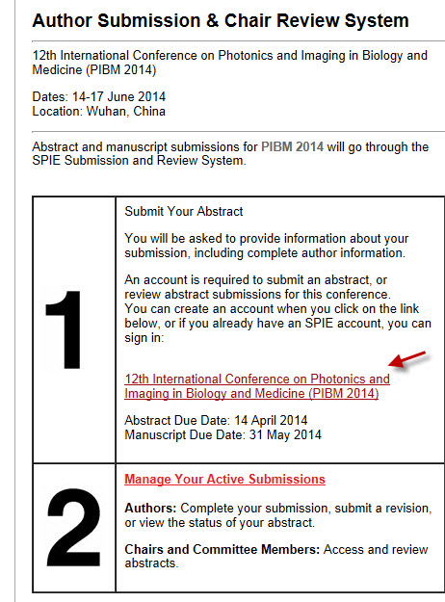

Sign In to SPIE.org.
If you do not yet have a SPIE account, then you must create an account.
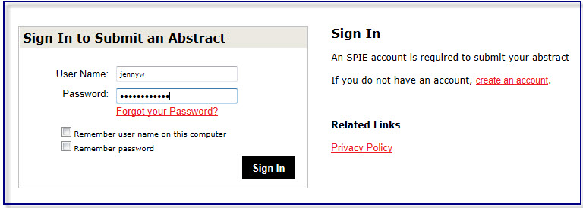

Submission Wizard Landing page
Enter your presentation’s title. Click green arrow ‘Next: Authors.’
If you are a student, please let us know if you want your paper considered for the Best Student Paper Award.
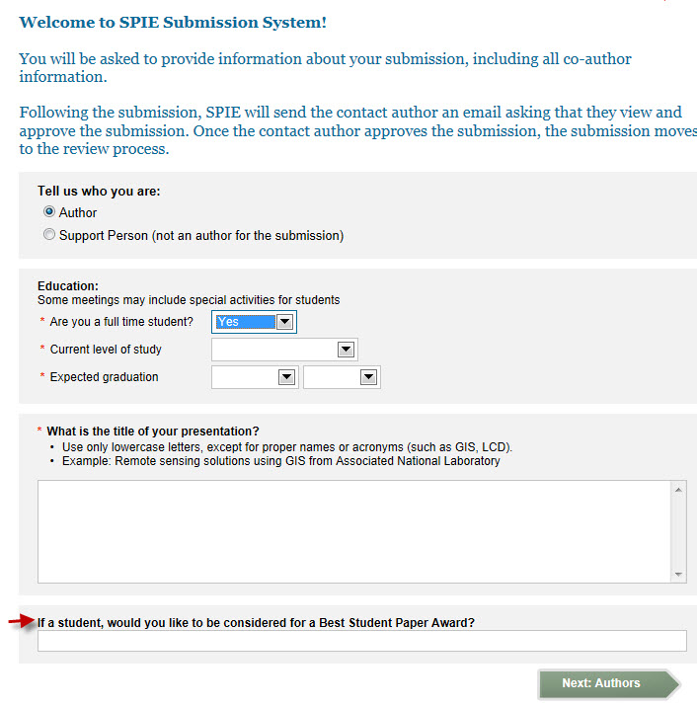
Enter author names.
Enter the speaker biography (optional). The bio has a limit of 1,000 characters.
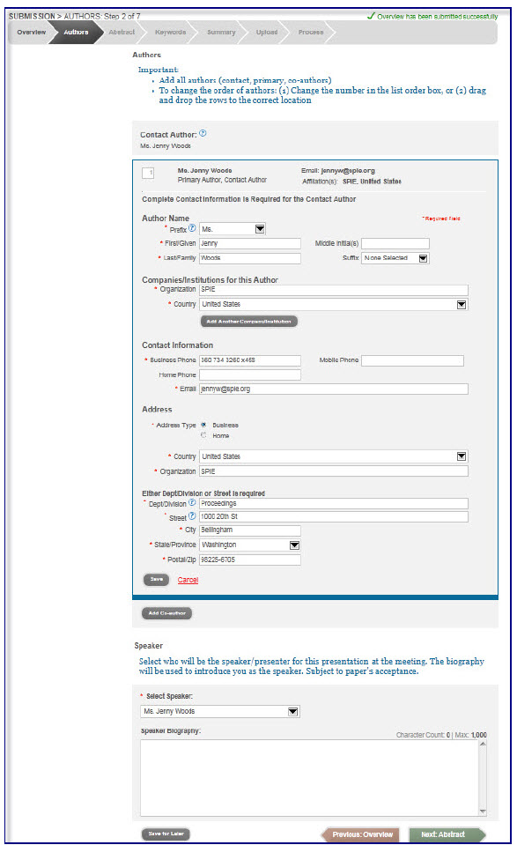
Choose presentation preference. Next, enter abstract text for both online program and for technical review.
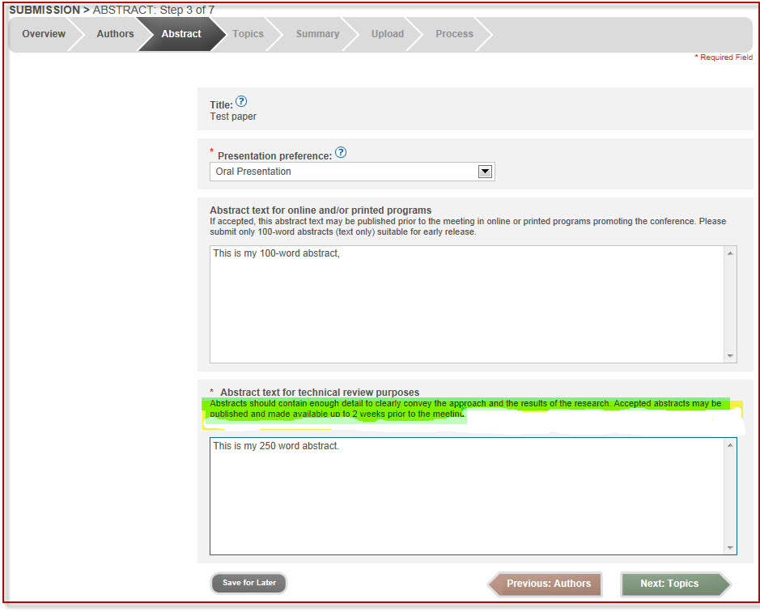

Topics and Key Words
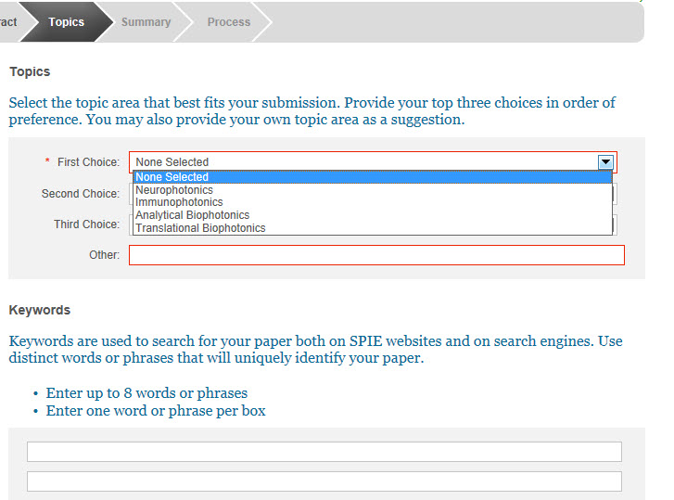

Review Abstract Summary
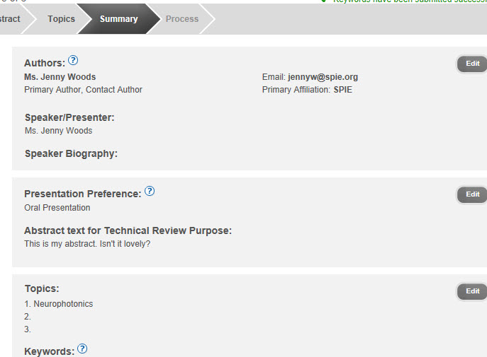

Finish
Your submission will automatically be assigned a tracking number. You may review your submission by going to http://spie.org/myaccount. Click ‘Manage Active Submissions.’

